Dear Westminster Park Resident,
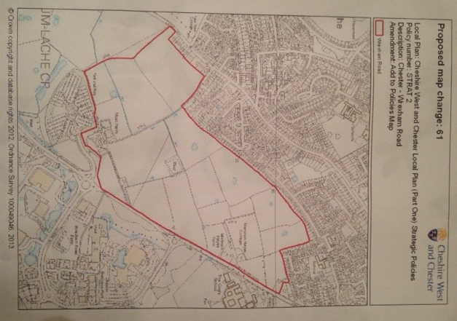
As you will already know from our most recent newsletter, the council are proposing to build 1300 houses on the <green belt> land behind Westminster Park up to the Chester Business Park – shown in the outlined red area of this map. This proposal is part of the draft ‘Cheshire West & Chester Local Plan’.
The Westminster Park Resident’s Association has found this plan is not justified or effective and has prepared a template letter of objection based on the research of residents in our area.
A meeting has been arranged for 7.45pm on Tuesday 29th October with our local councillors, to discuss this letter, drop-off your signed copy, the background to it and the actions that you can take to ensure your point of view is heard. The deadline for receipt of responses by CWaC is 1st November.
We have discussed at length future potential issues such as transport, drainage, and education in our area, but these will not be dealt with as part of our response (or ‘representation’) to this local plan. The process to deal with these issues comes later, after the local plan to build on the green belt land has been agreed.
How to use the template letter:
Write your Name and address in the top right hand corner

Dear Jeremy Owens,

I object to the re-designation of Green belt land by Wrexham Road as part of the CWaC local plan.

The local plan is NOT sound because;
- The plan is not ‘positively prepared’ as there is no evidence that the Council has co-operated with neighbouring authorities as required by the 'Duty to Co-operate'.

- The plan is not ‘justified’, because the trigger for re-designation of Greenbelt is the loading of the first five years not only with shortfall recovery but also an additional 1600 houses for managed trajectory allowance.

- The plan is not ‘justified’ because the need for houses has been exaggerated by a significant number (contingency on contingency).
  - Employment peaked around 2007 but houses were built between 2007 and 2010 (start of the local plan) = estimated at approx 1500–2000 (actual numbers not given in plan documentation)
  - Structural over-supply of labour in the models results in 2130 additional houses in the 0.4% growth scenario. This scenario is the closest to the 1100p.a. dwelling led plan chosen.
  - The additional allowance for managed delivery is ~1600 houses added to the first five years
  - Windfall sites could be included after year 3 of the plan, but have not been included at all. This would amount to 5321 dwellings in the plan period, based on the 2009-2012 average windfall and garden site delivery of 313 houses per annum.

- The plan is not ‘effective’ as there is a high probability that delivering the 6.6 years target in years 2 to 5 as planned (4years of the first 5) will not be achievable. It is simply not a credible plan given recorded past delivery levels.
  - Clearly a more credible, manageable and deliverable phasing can be made over the full 20 year period of the plan. These alternatives would not require Greenbelt land as the SHLAA also shows there is no shortage of land availability over the full 20 year period of the plan.

The case for re-designating the Wrexham Road Green belt has not been made.

Regards,
Sign your name at the bottom
…then send to:
Spatial Planning, The Forum Offices, Chester CH1 2HS

Should you wish to customise the letter (recommended) then download it from our web site at www.wp-ra.org.uk edit and send to spatialplanning@cheshirewestandchester.gov.uk

Jeremy Owens
Spatial Planning
The Forum Offices
Chester
CHI 2HS

Dear Jeremy Owens,

I object to the re-designation of Green belt land by Wrexham Road as part of the CWaC local plan.

The local plan is NOT sound because;

- The plan is not ‘positively prepared’ as there is no evidence that the Council has co-operated with neighbouring authorities as required by the 'Duty to Co-operate'.

- The plan is not ‘justified’, because the trigger for re-designation of Greenbelt is the loading of the first five years not only with shortfall recovery but also an additional 1600 houses for managed trajectory allowance.

- The plan is not ‘justified’ because the need for houses has been exaggerated by a significant number (contingency on contingency).
  - Employment peaked around 2007 but houses were built between 2007 and 2010 (start of the local plan) = estimated at approx. 1500–2000 (actual numbers not given in plan documentation)
  - Structural over-supply of labour in the models results in 2130 additional houses in the 0.4% growth scenario. This scenario is the closest to the 1100p.a. dwelling led plan chosen.
  - The additional allowance for managed delivery is ~1600 houses added to the first five years
  - Windfall sites could be included after year 3 of the plan, but have not been included at all. This would amount to 5321 dwellings in the plan period, based on the 2009-2012 average windfall and garden site delivery of 313 houses per annum.

- The plan is not ‘effective’ as there is a high probability that delivering the 6.6 years target in years 2 to 5 as planned (4 years of the first 5) will not be achievable. It is simply not a credible plan given recorded past delivery levels.
  - Clearly a more credible, manageable and deliverable phasing can be made over the full 20 year period of the plan. These alternatives would not require Greenbelt land as the SHLAA also shows there is no shortage of land availability over the full 20 year period of the plan.

The case for re-designating the Wrexham Road Green belt has not been made.

Regards,

